**Assignment 3 QUESTIONS:**

1.Create a Bucket in IBM object storage.

2.Upload an 5 images to ibm object storage and make it public. write html code to displaying all the 5 images.

3.Upload a css page to the object storage and use the same page in your HTML code.

4.Design a chatbot using IBM Watson assistant for hospital. Ex: User comes with query to know the branches for that hospital in your city. Submit the web URL of that chat bot as a assignment.

5.Create Watson assistant service with 10 steps and use 3 conditions in it. Load that script in HTML page.

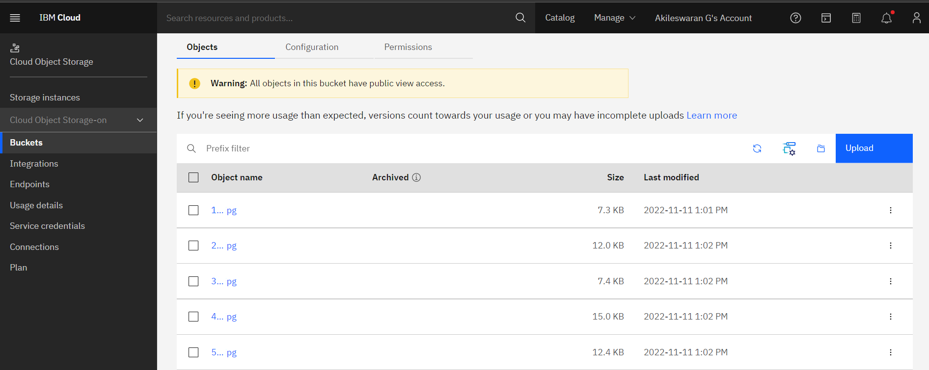

**HTML CODE:**

|  |
| --- |
| <html>   <head>   <title>IBM object storage-watson assistant</title>   <link rel="stylesheet" href="https://ibm-customer-care-registry.s3.jp-tok.cloud-object-storage.appdomain.cloud/style.css">   <script>      window.watsonAssistantChatOptions = {        integrationID: "efc238b4-6f5c-4044-a29a-0e45dc0317fe", // The ID of this integration.        region: "au-syd", // The region your integration is hosted in.        serviceInstanceID: "25b3728e-fa85-4836-aaf1-8da1af0760da", // The ID of your service instance.        onLoad: function(instance) { instance.render(); }      };      setTimeout(function(){        const t=document.createElement('script');        t.src="https://web-chat.global.assistant.watson.appdomain.cloud/versions/" + (window.watsonAssistantChatOptions.clientVersion || 'latest') + "/WatsonAssistantChatEntry.js";        document.head.appendChild(t);      });    </script>   <body>   <h3>IMAGE 1</h3>   <img src="https://ibm-customer-care-registry.s3.jp-tok.cloud-object-storage.appdomain.cloud/100.jpg" width="300" height="200"><br><br>   <h3>IMAGE 2</h3>   <img src="https://ibm-customer-care-registry.s3.jp-tok.cloud-object-storage.appdomain.cloud/200.jpg" width="300" height="200"><br><br>   <h3>IMAGE 3<h3>   <img src="https://ibm-customer-care-registry.s3.jp-tok.cloud-object-storage.appdomain.cloud/300.jpg" width="300" height="200"><br><br>   <h3>IMAGE 4</h3>   <img src="https://ibm-customer-care-registry.s3.jp-tok.cloud-object-storage.appdomain.cloud/400.jpg" width="300" height="200"><br><br>   <h3>IMAGE 5</h3>   <img src="https://ibm-customer-care-registry.s3.jp-tok.cloud-object-storage.appdomain.cloud/500.jpg" width="300" height="200"><br><br>   </body>   </head>  </html> |

**OUTPUT:**

